Ellison View Surgery
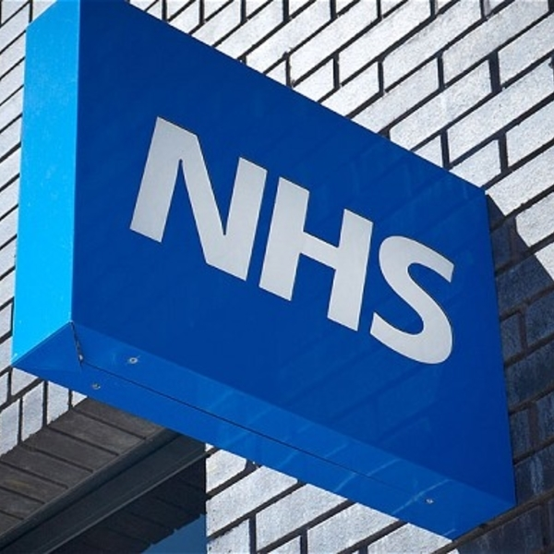

  - Privacy Information Leaflet
Ellison View Surgery
Campbell Park Road
Hebburn
NE31 2Sp
0191 2831610
www.ellisonviewsugery

What is a privacy notice?
A privacy notice is a statement that discloses some or all of the ways in which the practice gathers, uses, discloses and manages a patient’s data. It fulfils a legal requirement to protect a patient’s privacy.

Why do we need one?
To ensure compliance with the General Data Protection Regulation (GDPR), Ellison View Surgery must ensure that information is provided to patients about how their personal data is processed in a manner which is:
- Concise, transparent, intelligible and easily accessible;
- Written in clear and plain language, particularly if addressed to a child; and
- Free of charge

What is the GDPR?
The GDPR replaces the Data Protection Directive 95/46/EC and is designed to harmonise data privacy laws across Europe, to protect and empower all EU citizens’ data privacy and to reshape the way in which organisations across the region approach data privacy. The GPDR comes into effect on 25 May 2018.

How do we communicate our privacy notice?
At Ellison View Surgery, the practice privacy notice is displayed on our website, through signage in the waiting room, and in writing during patient registration (by means of this leaflet). We will:
- Inform patients how their data will be used and for what purpose
- Allow patients to opt out of sharing their data, should they so wish

What information do we collect about you?
We will collect information such as personal details, including name, address, next of kin, records of appointments, visits, telephone calls, your health records, treatment and medications, test results, X-rays, etc. and any other relevant information to enable us to deliver effective medical care.

How do we use your information?
Your data is collected for the purpose of providing direct patient care; however, we can disclose this information if it is required by law, if you give consent or if it is justified in the public interest. The practice may be requested to support research; however, we will always gain your consent before sharing your information with medical research databases such as the Clinical Practice Research Datalink and QResearch or others when the law allows.

Maintaining confidentiality
We are committed to maintaining confidentiality and protecting the information we hold about you. We adhere to the General Data Protection Regulation (GDPR), the NHS Codes of Confidentiality and Security, as well as guidance issued by the Information Commissioner’s Office (ICO).

Risk stratification
Risk stratification is a mechanism used to identify and subsequently manage those patients deemed as being at high risk of requiring urgent or emergency care. Usually this includes patients with long-term conditions, e.g. cancer. Your information is collected by a number of sources, including Ellison View Surgery; this information is processed electronically and given a risk score which is relayed to your GP who can then decide on any necessary actions to ensure that you receive the most appropriate care.

Invoice validation
Your information may be shared if you have received treatment, to determine which Clinical Commissioning Group (CCG) is responsible for paying for your treatment. This information may include your name, address and treatment date. All of this information is held securely and confidentially; it will not be used for any other purpose or shared with any third parties.

Opt-outs
You have a right to object to your information being shared. Should you wish to opt out of data collection, please contact a member of staff who will be able to explain how you can opt out and prevent the sharing of your information; this is done by registering a Type 1 opt-out, preventing your information from being shared outside this practice.

Accessing your records
You have a right to access the information we hold about you, and if you would like to access this information, you will need to complete a Subject Access Request (SAR). Please ask at reception for a SAR form and you will be given further information. Furthermore, should you identify any inaccuracies, you have a right to have the inaccurate data corrected.

What to do if you have any questions
Should you have any questions about our privacy policy or the information we hold about you, you can:
- Contact the practice’s data controller at North East Commission Support. GP practices are data controllers for the data they hold about their patients
- Write to the data controller at John Snow House, Durham, DH1 3YG
- Ask to speak to the practice manager Mrs J Mahon

The Data Protection Officer (DPO) for Ellison View Surgery is NECS and he/she is based at North East Commission Support.

Complaints
In the unlikely event that you are unhappy with any element of our data-processing methods, you have the right to lodge a complaint with the ICO. For further details, visit ico.org.uk and select ‘Raising a concern’.
We regularly review our privacy policy and any updates will be published on our website, in our newsletter and on posters to reflect the changes. This policy is to be reviewed on 1st July 2018.

BMA GPs as data controllers under the GDPR

